Role of Continuous Testing in DevOps

Continuous Testing acts as the quality gatekeeper in DevOps. It ensures that software remains stable, secure, and functional as it moves through development, integration, and deployment. By testing at every step, Continuous Testing helps catch issues early so that only the best code is delivered.
Here are the key testing Types stages which are used to step up with flow of testing:

- Unit Testing: This is like checking each small piece or function of the code individually. It makes sure every tiny part works correctly on its own.
- Integration Testing: Once the individual pieces pass, they are combined. Integration Testing checks if these pieces work well together.
- Functional Testing: This stage verifies that the software meets the business needs. It ensures that all the features behave as expected.
- Performance Testing: Here, the focus is on how fast the application runs and how well it scales under load. It checks the speed and reliability when many users are involved.
- Security Testing: This testing looks for any vulnerabilities. It ensures that the software is secure and follows all the necessary compliance rules.
- Regression Testing: Every time new changes are made, Regression Testing confirms that these changes haven’t disrupted the existing features.
- User Experience (UX) Testing: This ensures that the software is easy to use. It checks if the design is user-friendly and accessible for everyone.
- By embedding these testing stages throughout the process, Continuous Testing guarantees that only high-quality code moves forward, keeping the software reliable and user-friendly.

Continuous Testing vs. Traditional Testing
Continuous Testing is a modern approach that stands out from traditional testing methods in several ways:
Aspect | Continuous Testing | Traditional Testing
When testing occurs | Runs continuously throughout development | Happens after development as a separate phase
Automation | Heavy reliance on automated testing | May involve automation but often manual
Feedback | Instant feedback on code changes | Feedback comes later in the process
Integration with DevOps | Essential part of CI/CD pipelines | Typically separate from development
Speed & efficiency | Optimized for rapid software delivery | Slower due to manual processes
Risk mitigation | Catches issues early, reducing failures | Issues may remain undetected until later

Continuous testing in DevOps offers significant benefits, but there are several challenges:
- Resistance to Change: Teams accustomed to traditional testing may struggle with the cultural shift required for continuous testing.
- Lack of Knowledge: There may be insufficient understanding of the tools needed for continuous testing in DevOps and Agile environments.
- Integration Issues: Developers who prefer integrating code at the end might face duplication or compatibility problems with continuous testing.
- Ineffective Strategy: Traditional testing strategies and test data management may hinder the full potential of continuous testing if not adapted.
- Environment Compatibility: The test and production environments need to be aligned with the code repository to ensure proper testing with the most up-to-date code.
Some of the key benefits of Continuous Testing in DevOps include:
- Early Discovery of Bugs: Identifies issues early in the development process, reducing the cost and effort required to fix them later.
- Seamless Collaboration: Encourages teamwork between developers, testers, and operations, fostering a culture of shared responsibility for quality.
- Improved Code Quality: Continuous feedback and repeated testing ensure minimal failure rates for new releases.
- Faster Time to Market: Accelerates the delivery of robust, user-friendly software by providing rapid feedback throughout the development cycle.

Architectural rules of thumb in devops
In DevOps, there are several architectural rules of thumb to ensure smooth collaboration, automation, and scalability. Here are some key principles:
- Microservices Architecture: Break down applications into smaller, independently deployable services. This allows for better scalability, maintainability, and flexibility in development and deployment.
- Automate Everything: Automate all stages of the DevOps pipeline, from code integration and testing to deployment and monitoring. Automation reduces human error, speeds up processes, and ensures consistency.
- Infrastructure as Code (IaC): Use IaC tools (e.g., Terraform, Ansible, or CloudFormation) to manage infrastructure through code, enabling version control, reproducibility, and automation of environment setups.
- Continuous Integration and Continuous Deployment (CI/CD): Implement CI/CD pipelines for seamless code integration, testing, and deployment. This ensures faster and more reliable releases with minimal manual intervention.
- Version Control for All: Version control should be used not only for code but also for configuration files, infrastructure, and scripts. This ensures traceability and facilitates collaboration across teams.
- Monitoring and Feedback Loops: Integrate continuous monitoring into the architecture to provide real-time feedback on system performance, user experience, and potential issues. This ensures proactive problem resolution.
- Resilience and Fault Tolerance: Design systems to be fault-tolerant and resilient. Use practices such as redundancy, automated failover, and graceful degradation to ensure availability and reliability even in the face of failures.
- Immutable Infrastructure: Avoid manual updates to production systems. Instead, replace servers or containers with updated versions. This ensures consistency and reduces configuration drift.
- Security by Design (DevSecOps): Integrate security practices into every stage of the DevOps pipeline. Security should be a core consideration in both the architecture and the development lifecycle.
- Containerization: Use containers (e.g., Docker) for consistent environments across development, testing, and production. Containers help eliminate environment-related issues and improve scalability.
- Decentralized Ownership: Empower teams to own the entire lifecycle of their services, from development to deployment and monitoring. This promotes accountability and faster iteration.
- Scalable and Elastic Design: Design systems that can scale horizontally (adding more instances) to handle increased loads. Cloud-native designs often make use of elasticity to efficiently manage resources.
Separation of Concerns (SoC) in software architecture
Separation of Concerns (SoC) in software architecture is a design principle that involves dividing a software system into distinct sections, where each section (or "concern") addresses a specific aspect of the system's functionality. This helps to reduce complexity and improve maintainability, scalability, and flexibility by ensuring that each part of the system can be developed, modified, and understood independently. Here’s how SoC plays out in software architecture:

Key Principles of Separation of Concerns:
Modularization: Break down the system into independent modules or components. Each module should have a well-defined responsibility and handle a specific aspect of the application (e.g., user interface, business logic, data access, etc.).
Example: In a web application, separate modules for user authentication, database interactions, and UI rendering.
Layered Architecture: Organize the system into layers, where each layer has a specific responsibility and interacts only with adjacent layers. Common layers include:
    - Presentation Layer: Handles the user interface and user interactions.
    - Business Logic Layer: Manages core application logic and workflows.
    - Data Access Layer: Interacts with databases or other external data sources.
Example: The Model-View-Controller (MVC) architecture is a layered approach, where the Model handles the business logic, the View manages the presentation, and the Controller coordinates input.
Separation Between Business Logic and Infrastructure: Keep the application’s business rules and logic independent from infrastructure concerns like networking, logging, or persistence mechanisms. This allows business logic to evolve independently of changes to the infrastructure.
Example: Use Dependency Injection (DI) to inject infrastructure-related components, such as database connections, into the core business logic without directly coupling them.
Decoupling of User Interface and Logic: Separate the user interface from the application’s business logic and backend services. This enables independent changes to UI without affecting the underlying logic and vice versa.
Example: In a web application, use an API (REST, GraphQL) to decouple the backend (business logic) from the frontend (UI).
Encapsulation: Each component or module should hide its internal implementation details and only expose the necessary interfaces. This improves maintainability and allows teams to focus on specific concerns without worrying about the internal workings of other modules.
Example: A service class that interacts with a database should only expose methods like save(), find(), and delete() rather than direct database manipulation details.

Benefits of Separation of Concerns:
- Maintainability: Easier to maintain and modify individual components without affecting other parts of the system.
- Scalability: Independent components can be scaled as needed (e.g., scaling the database layer without affecting the UI).
- Reusability: Modular components can be reused across different parts of the application or even in other projects.
- Testability: Independent modules with clearly defined responsibilities are easier to test in isolation.
- Flexibility: Changes or replacements in one module (e.g., switching to a different database) can be done with minimal impact on other modules.

Real-World Examples of Separation of Concerns:
- Web Development: Using the MVC architecture (Model-View-Controller) to separate data handling (Model), user interface (View), and user input (Controller).
- Microservices: Each microservice handles a specific domain (e.g., user authentication, payment processing), ensuring that business concerns are isolated.
- Service-Oriented Architecture (SOA): Services are separated based on their functionality, such as an inventory service, payment service, etc.

Handling database migration in devops:
Handling database migration in DevOps can be a challenging yet critical part of the CI/CD pipeline. Effective database migration ensures that changes to the database schema or data are safely and seamlessly deployed without impacting application performance or user experience. Below are best practices and strategies for managing database migrations in a DevOps environment:

1. Version Control for Database Schema
- Use Version Control for Database Changes: Just like application code, database schema changes (e.g., table modifications, indexes) should be tracked in version control (e.g., Git). This ensures that all changes are documented, auditable, and consistent across environments.
- Store Migration Scripts: Store database migration scripts (SQL files, schema changes, data migration scripts) alongside your application code, organized in versioned directories.
- Automate Database Schema Versioning: Use database versioning tools like Liquibase or Flyway to manage database schema changes in a consistent way.

2. Database Migration Tools
- Flyway: Flyway is a popular open-source database migration tool that allows you to version control your database schema by writing SQL scripts (or Java code) that apply changes incrementally.
- Liquibase: Liquibase is another tool that helps with database version control, offering additional flexibility and features, such as the ability to generate SQL from changelogs.
- Alembic (for Python): Alembic is a lightweight database migration tool for SQLAlchemy, useful for Python-based applications.
- DBMaestro, Redgate SQL Compare: These tools are designed to handle database changes and automate deployments to various environments.

3. CI/CD Pipeline Integration
- Automate Database Migrations in CI/CD: Incorporate database migration scripts into your CI/CD pipeline to ensure that migrations are automatically applied during every deployment. This can help catch issues early in the development process.
  - Before Deployment: Run migration scripts on the target environment to ensure that the database schema is up-to-date before deploying the application.
  - During Deployment: Use deployment scripts that automatically apply changes to the database as part of the deployment process.
  - After Deployment: Ensure that the application is tested with the new database schema to catch issues that could arise from the migration.
- Rollback Strategy: Ensure that your pipeline supports rollbacks of both the application code and the database schema. You can do this by storing rollback scripts or using tools like Flyway and Liquibase, which provide support for rolling back database changes.

4. Handling Schema and Data Changes
- Non-Disruptive Changes: In a microservices or DevOps environment, it's essential to make database changes in a non-disruptive way. Avoid breaking changes that would require downtime. Use techniques like:
  - Additive Changes: Add new columns or tables rather than removing or renaming them. For example, add a new column and fill it with default values instead of changing an existing column.
  - Backward Compatibility: Keep old versions of the schema running alongside new versions. This allows both old and new code to coexist while ensuring that migrations do not disrupt ongoing operations.
  - Data Migrations: For complex data migrations, perform them in small, incremental steps to minimize the risk of downtime and data corruption.

5. Environments and Rollout Strategy
- Multiple Environments: Ensure that your migration scripts work across all environments (development, staging, production). This can be achieved by having clear, repeatable processes for applying migrations in each environment.
  - For instance, applying migrations to a staging environment first helps to catch issues before deploying to production.
- Blue/Green or Canary Deployments: Use deployment strategies like Blue/Green or Canary Deployments for database migrations to minimize risk. This allows for testing the migration in a subset of production traffic or a separate environment before full rollout.
- Database Cloning: For safety, you can clone production databases to staging environments for testing migrations on real-world data before applying them.

6. Handling Schema Evolution in Microservices
- Dealing with Multiple Databases: In a microservices architecture, each service may have its own database. Each microservice should handle its schema migration independently, and coordination between different services should be done through API versioning or eventual consistency mechanisms.
- Database Per Service: Ensure that each microservice uses its own database and handles its migrations independently to avoid conflicts and downtime across services.
- Service-Level Migrations: Use techniques such as Database Per Service or Event Sourcing where microservices update their databases via events rather than direct schema changes.

7. Monitoring and Validation
- Automated Tests for Migrations: Use automated testing to validate that database migrations do not break the system. Write tests to check that the schema changes have been applied correctly and that the application can work with the updated schema.
- Monitoring: After a migration is applied, monitor the system for performance issues or errors that could arise from the changes. This includes database performance monitoring (e.g., slow queries, locking issues) and application-level monitoring (e.g., API responses, user feedback).
- Alerting: Set up alerting for any failed migrations or schema changes that do not apply correctly to ensure that issues are detected early.

8. Handling Data Integrity
- Data Integrity Checks: After running migrations, always validate that the data is still consistent. This can include checking for missing records, data corruption, or referential integrity issues.
- Data Cleanup: If necessary, plan for cleanup scripts to remove obsolete columns or tables, but only after the migration has been fully tested and validated in lower environments.

9. Versioning and Rollbacks
- Incremental Migrations: Use versioned migration scripts that are applied incrementally. This ensures that all changes are tracked and can be rolled back to previous versions if necessary.
- Rollback Scripts: Always write rollback scripts for each migration. If an issue occurs during deployment, you can easily revert the database to its previous state.
  - Example: If you add a new column to a table, write a corresponding rollback script to drop the column if needed.

What is a Monolithic Architecture?
Software is traditionally designed using a monolithic architecture, in which the entire program is constructed as a single, indivisible unit. Every component of the program, including the data access layer, business logic, and user interface, is deployed and integrated tightly together in this design.
- This means that any changes or updates to the application require modifying and redeploying the entire monolith.
- Monolithic architectures are often characterized by their simplicity and ease of development, especially for small to medium-sized applications.
- However, they can become complex and difficult to maintain as the size and complexity of the application grow.
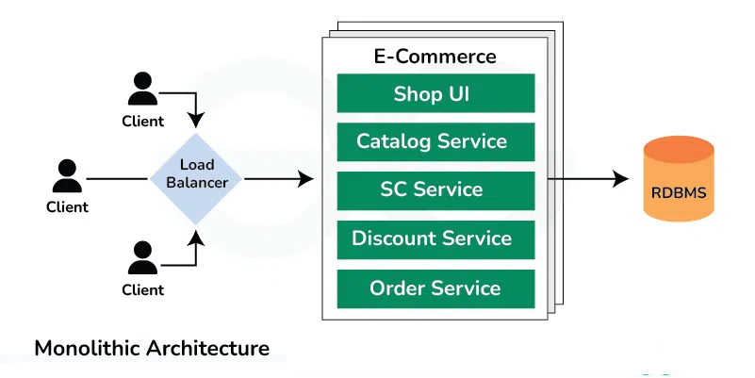

What is a Microservices Architecture?
A microservices architecture results in an application designed as a set of small, independent services. Each one represents a business capability in itself. The services loosely couple with one another and communicate over the network, typically making use of lightweight protocols such as HTTP or messaging queues.
- Each service is responsible for a single functionality or feature of the application and can be developed, deployed, and scaled independently.
- The Microservice architecture has a significant impact on the relationship between the application and the database.

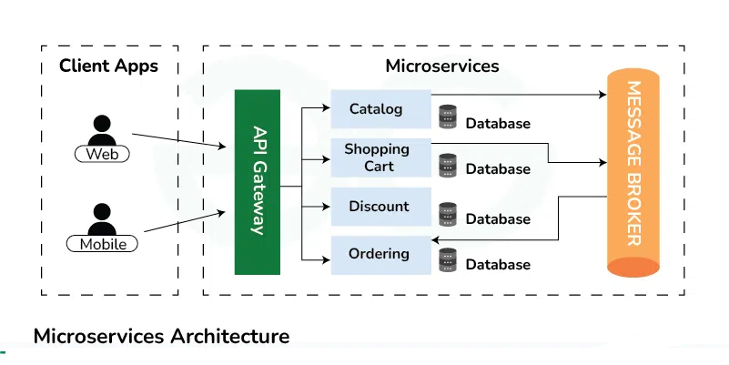

Differences between Monolithic and Microservices Architecture
Below are the differences the Monolithic and Microservice architecture:
Aspect | Monolithic Architecture | Microservice Architecture
Architecture | Single-tier architecture | Multi-tier architecture
Size | Large, all components tightly coupled | Small, loosely coupled components
Deployment | Deployed as a single unit | Individual services can be deployed independently
Scalability | Horizontal scaling can be challenging | Easier to scale horizontally
Development | Development is simpler initially | Complex due to managing multiple services
Technology | Limited technology choices | Freedom to choose the best technology for each service
Fault Tolerance | Entire application may fail if a part fails | Individual services can fail without affecting others
Maintenance | Easier to maintain due to its simplicity | Requires more effort to manage multiple services
Flexibility | Less flexible as all components are tightly coupled | More flexible as components can be developed, deployed, and scaled independently
Communication | Communication between components is faster | Communication may be slower due to network calls

Best Scenarios for Monolithic and Microservices Architecture
Below are the best scenarios where we can use Monolithic Architecture or Microservices Architecture:
